“Comparison of Schobinger Incision and MacFee Incision In Neck Dissection- A Prospective Study”
Abstract: Objectives There are many incisions that are most commonly recommended for performing neck dissection for oral cancer. The need towards more conservative surgical treatment of oral cancer has led to performing various incisions.
Methods: In this study Schobinger , MacFee Incisions are used in the RND are compared during Intra operative and Post operative and during follow up at regular intervals. The study was conducted from November 2011 to June 2013, on 30 patients who were biopsy proven case of SCC. Age group 20 to 60 yrs both Male and Female. 15 patients each were randomly sorted into Schobinger incision group and MacFee incision group.
Result: Schobinger incision (Group I) and MacFee incision (Group II) both had 12 males and 3 females. Further the results were tabulated on the following parameters, Time taken to raise and closure of flap, Dehiscence, Marginal necrosis of the flap, Contraction of wound, Infection, Scar assessment.
Conclusion: In MacFee incision there was a better cosmetic result, the time taken to rise and closure of the flap was less, and post operative healing was better achieved when compared to Schobinger incision. The Schobinger incision provided a better exposure of neck during dissection, but higher incidence of marginal necrosis and contracture of the flap with scaring was noted. In MacFee incision there was difficulty noted under the bridge flap and in posterior triangle during neck dissection, but it provided a better cosmetic and very minimal scaring was noted.
Keys words: Schobinger Incision (Group I) MacFee Incision (Group II) Neck Dissection, Healing, Scar assessment.
Advances in Knowledge: This study gives us the results of the healing of the skin incision used in Neck Dissection and the exposure of the neck and the difficulties faced during the neck dissection due to design of the Incisions.
Application to Patient Care: The healing ,Scar formation, contracture in the neck region and the outcome of scar and contracture post operative.
Introduction: The 1st Radical neck dissection (RND) was described by Jawdynsky in 1888, in Poland .And later described by Crile in 1906 (George Crile). A number of skin incisions have been used to obtain exposure for the required neck dissection. One of the first to mention an incision of the neck, in connection with tumour of the mouth, was Regnoli of Pisa in 1838. He described a T shaped incision made under the chin for the removal of tumour of the tongue.²
There are many incisions that are used for neck dissection in Oral Cancer. The incisions that were designed to perform neck dissection have remained unchanged over the past 3 decades. The use of different incisions to perform current standard neck dissection must be re-evaluated. Preoperative planning is required for the success and the outcome of the patient. Depending on the Intraoperative findings, during Neck Dissectiion which allows a good exposure of the operative site and a safe, lymphadenectomy. Some incisions which are used for neck dissection provide excellent exposure during dissection at the expense of Esthetical outcomes. Some incisions, which provide a good exposure to all areas of the neck are also prone to wound dehiscence which require additional care and stay in hospital for a longer time and scar contracture are also seen which causes difficulty in neck movements .
The ideal skin incision for radical or modified radical neck dissection should maintain adequate skin viability, Provide adequate exposure and coverage of the carotid artery, Allow transfer of appropriate flaps to head and neck region for reconstruction, good cosmetic results.³
Schobinger Incision: The horizontal limb of the incision follows the conventionally used slightly downward curved line leading from the tip of the mastoid process to the midline of the submental region. If there is need, the incision may be carried further along the undersurface of the chin to the opposite submandibular region. This extension will allow adequate retraction of the medial flap and permit satisfactory access to the opposite side of the neck such as may be required during more extensive procedures. The vertical limb of the incision starts approximately one finger breadth and behind the angle of the mandible and at right angles with the horizontal portion of the skin incision. It is in this respect very important to avoid acute angles, since narrow skin flaps have an increased tendency to slough. The incision is then carried along the edge of the trapezius muscle in a curved fashion down to the midline of the clavicle.

Macfee Incision: It’s a double Horizontal Incision, Where two incisions are made one in the upper cervical area beginning approximately 2.5 cms below and 2.5 cms behind the tip of the mastoid process and continuing below the angle of the mandible, then parallel to the lower margin of the mandible diverging slightly from it. The lower incision is made 3.5cms above the clavicle and parallel to it. This approach gives access to the cervical lymph nodes and vascular structures, muscles of the neck, and the submadibular region. This incision exposure may be difficult at times but a appealing cosmetic results can be achieved.

Objectives: The objective of the study is to compare Schobinger and Macfee incision used in Radical Neck Dissection for the better aesthetic outcome in patients. The need towards more conservative surgical treatment of oral cancer .

Material and methods:
Ethical Permission was obtained from the Institutional review board, and Informed consent for participation in the study was obtained from the patient
Prospective study was conducted on 30 Patients who reported with Oral SCC.The patients were divided randomly in to 2 groups. 15 patients operated using Schobinger incision and MacFee incision with 15 patients operated using MacFee incision.

Inclusion criteria: All patients undergoing only Radical neck dissection, Age 20 to 60 yrs 3, both sexes to be included.

Exclusion criteria: Patients who had undergone radiotherapy and chemotherapy pre operatively, Tumour mass sticking to the tissues, Patient undergoing bilateral neck dissection, N3 nodes involving important anatomical structures, Medically compromised patients.
Intra-operatively time taken to raise the flap, accessibility to the neck, damage to the IJV & the time to close the flap were analysed. The time to raise the flap was calculated from the start of the incision up to the point before starting the neck dissection from the lower end. The time taken for closure was calculated from the time of approximation of flap to the completion of the last skin suture.
Post operatively the patient was assessed at the time of discharge and at 1st, 3rd & 6th month follows up as well as post radiotherapy. The incision was assessed for marginal necrosis of flap, dehiscence and contraction of wound, Edema, Infection or any exposure of vessels. Cosmesis of Scar was assessed by Stony Brook Scale.
Statistics Evaluation was done using Non-parametric tests were used (Mann Whitney Test)

Results:
Schobinger incision (Group I) consisted of 12 males and 3 females; the mean age being 46.0 yrs with a standard deviation of ±12.6.MacFee incision (Group II) had 12 males and 3 males with the mean age of 51.6 yrs and a standard deviation of ±11.9.
In Schobinger incision site of lesion was in the buccal mucosa in 60% of patients, RMT in 6.7% patients, GB sulcus in 20% patients and tongue in 13.3% patients. In MacFee incision the lesion was involving buccal mucosa in 53.3% patients, GB sulcus in 6.7% patients, and tongue in 20% patients and combined (buccal mucosa and RMT) in 20 % patients.
In Schobinger incision the patients HPR with Well Differentiated SCC was 86.6% of the patients, moderately differentiated SCC was 6.7% and with poorly differentiated SCC was 6.7%. In MacFee incision all patients (100%) were with well differentiated SCC.
In Schobinger incision one patient was epileptic and one was diabetic. In MacFee incision one patient was hypertensive.

Time to raise the flap and closure of flap
The mean time to raise the flap in Schobinger Incision was 63.0 min with a standard deviation of ± 11.9, in MacFee Incision was 47.3 min with standard deviation of ± 5.3.(Graph I)
The mean time for the flap closure in Schobinger incision was 85.3 min with a standard deviation of ± 6.9, in MacFee incision was 62.0 min with a standard deviation of ± 6.7. (Graph I)
According To the Mann-Whitney Test the parameter such as time taken to raise the flap and time taken for flap closure between the two groups are statistically significant since the P Value of less than 0.005.
None of the patients in either of the Groups had any damage to anatomical structures. The IJV was preserved in all the cases, except for one case in MacFee incision. Preservation or removal of IJV did not show any significance in healing process in either of the group. There was edema noted in the patient in which IJV was removed which resolved over the period of time.
The healing of the incision was assessed postoperatively at the time of discharge and at regular intervals such as 1st, 3rd, 6th months and the following findings was noted:
Marginal necrosis and Dehiscence of the flap:
Marginal necrosis and Dehiscence was seen in 5 patients at the tri-furcation point in the Group I and in 1 patient in MacFee incision in the upper limb i.e. at the junction where the flap joins the bridge. The marginal necrosis and Dehiscence did not differ significantly since the P value was more then 0.005.
Contraction of wound:
Contracture of the wound was not seen in 3 patients due to infection at the tri-frication point in the Schobinger incision and in 1 patient in MacFee incision. The Contracture of the wound does not differ significantly since the P value was more then 0.005.
Infection:
Infection was seen in 3 patients in the Schobinger incision due to the systematic condition out of which 1 patient was suffering from Diabetes Mellitus and 2 patients without any underlying systematic diseases. In MacFee incision one patient had infection without any underlying systematic condition. The Infection of the wound does not differ significantly since the P value was more then 0.005.
Scar assessment:
In the post operative assessment at the time of discharge, the mean score for healing of the incision and the scar assessment in a scale of 0-5 at the time of discharge in Schobinger incision was 2.7 with a standard deviation of ± 0.8 and in MacFee incision was 3.2with a standard deviation of ± 0.6

1st Month Follow up
The 1st month follow up in Schobinger incision was 3.2 with a standard deviation of ± 0.5 and in MacFee incision was 3.9 with a standard deviation of ± 0.2

3rd Month Follow up
The 3rd month follow up in Schobinger incision was 3.4 with a standard deviation of ± 0.5 and in MacFee incision was 4.1 with a standard deviation of ± 0.5.

6th Month Follow up
The 6th month follow up in Schobinger incision was 3.6 with a standard deviation of ± 0.4 and in MacFee incision was 4.6 with a standard deviation of ± 0.4.
According to the Mann-Whitney Test the parameters of healing of the incision and the scar assessment between the two Groups differ significantly since all P values are less than 0.05 except at the time of discharge.(Graph II)
Out of 15 patients in the Schobinger incision, 11 patients underwent radiotherapy. In MacFee incision, 13 patients underwent radiotherapy out of which 2 patients had undergone chemotherapy as well. In both the groups the Radiotherapy and Chemotherapy did not make any significance in the healing of the flap. The P value of the Radiotherapy and Chemotherapy patients was more than 0.05 and hence the groups do not differ significantly
Statistics Non-parametric tests were used (Mann Whitney Test)
Graph I

Graph II

Schobinger Incision (Group I)
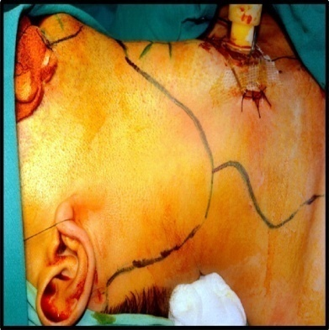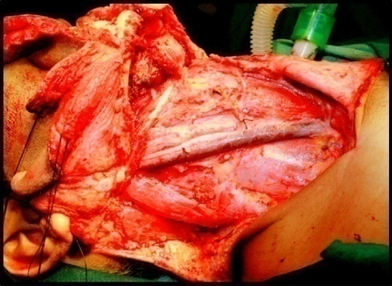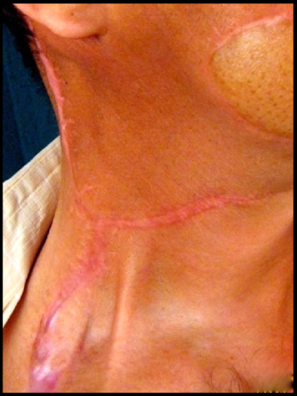
Marking of Incision After Neck Dissection 6 Month follow up
MacFee Incision (Group II)
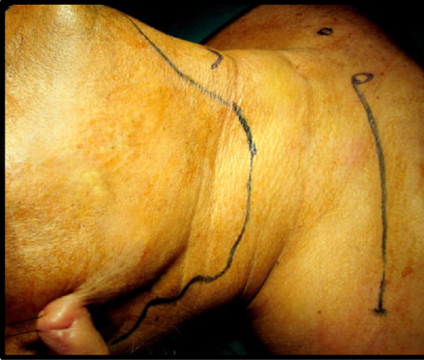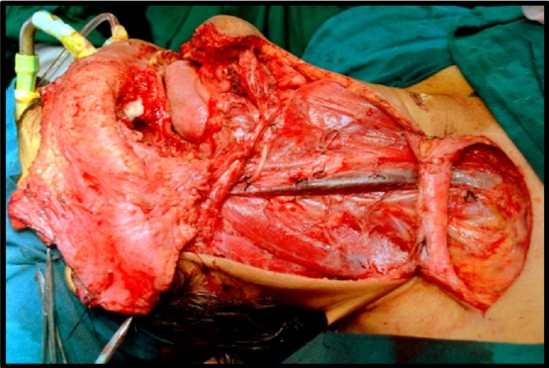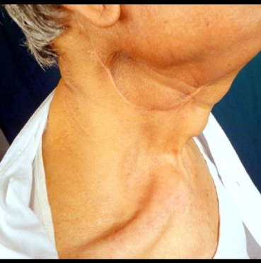
Marking of Incision After Neck Dissection 6 Month follow up
Dissucssion:
The total of 24 male and 6 female patients were operated in our unit from November 2011 to June 2013. The mean age, was 48.8 yrs.
In Schobinger incision 6 people and in Macfee incision 5 people had under gone elective tracheostomy.
The raising of the flap was done by a single surgeon. The time to raise the flap was calculated from the start of the Incision up to the point before starting the neck dissection from the lower end. In both the groups, the incision was extended up to the lower border of the mandible above and the insertion SCM below. Time in both the incisions differed significantly, being more for the Schobinger incision than MacFee incision.
Considering the accessibility of the structures of the neck, Schobinger incision had a good exposure of the neck and all the 4 levels of lymph nodes were clearly seen under the direct vision. In both the incisions while raising the flap there was no anatomical damage noted to the vessels or nerves directly while raising the flap.

In Schobinger incision all patients under went MRND i.e. IJV preserving and in MacFee incision 14 patients were treated with MRND i.e. IJV preserving and 1 patient underwent RND but there was no significance in the healing process. There was edema noted in the patient in which IJV was removed which resolved over the period of time.

After the clearance of the neck nodes and the resection of the primary tumour were done, primary reconstruction of the defect was done using free flap, regional flap or skin graft. Before the closure began, suction drains were placed, one in the submandibular region and one in the posterior triangle not crossing the IJV and the Carotid vessels and secured using silk suture. The closure of the incision was done using 3-0 vicryl for the platysmal layer and 3-0 silk for the skin. The time taken for closure in both the incision differed significantly being more for Schobinger incision than MacFee incision.

The marginal necrosis of the flap was seen in 5 patients of the Schobinger incision at the time of discharge i.e. between the 8 to 12 days post OP at the trifurcation point.⁹ this healed over the period of time. It was seen in one case of MacFee incision. The P value of the comparison between the incisions was 0.06 which was not significant.

In Schobinger incision dehiscence was seen, and marginal necrosis occurred at the trifurcation in 5 patients, and with 1 patient in MacFee incision. Regular dressing was done in these patients and healing occurred over the period of time.³
Wound contraction was seen in 12 patients of Schobinger incision with a minimal dehiscence in 3 patients which healed in 20 ± 3 days of post OP and in MacFee incision contraction of wound was present in 14 patients and in only one patient there was minimal dehiscence of the wound, which healed over the period of time.⁵

Wound infection was seen in 3 patients of Schobinger incision, in whom marginal necrosis, dehiscence and contraction of the wound were not present and which healed in 20 ± 3 days of post OP. In MacFee incision infection of wound was present in 1 patient, in both the upper and lower incisions.⁵

The cosmesis of the scar was better in MacFee incision then Schobinger incision, vertical contracture band was noted in Schobinger incision in some cases, where as MacFee incision did not have any contracture. The cosmesis of the scar in MacFee incision at the end of 6 months showed a mean score of 4.6 ± 0.4 of a score of 5 according to stony brook then Schobinger incision with a mean score of 3.6 ± 0.4.

In our study total of 6 patients did not undergo radiotherapy, out of which 4 patients were in Schobinger incision and 2 in MacFee incision. The patients who underwent radiotherapy did not have any complication with the healing of the incision lines; neither did the patients who did not receive radiotherapy. We neither found any exposure of the vessels in both the incisions.

Conclusion of the Study
To conclude in the present study Schobinger incision provided a better exposure of neck during dissection, higher incidence of marginal necrosis and contracture of the flap with scaring was noted. While in MacFee incision there was difficulty noted under the bridge flap and in posterior triangle during neck dissection, but it provided a better cosmetic and very minimal scaring was noted.

Acknowledgement: There was no funding agency. There was no remuneration received by any authors.
Informed consent: Both verbal and written consent was taken from the patient and patient party
Conflict of Interest: There is no conflict of interest.

References
1. Robert Schobinger. The Use of a Long Anterior Skin Flap in Radical Neck Resections. Annals of Surgery 1957; 146: 221-223.

2. William F. MacFee. Transverse Incisions for Neck incision. Annals of Surgery 1960; 151: 279-284.

3. Keith White, Shreveport La; Dale M. Mosdell , and Don Morris, MD, Albuquerque, NM. MacFee Incision: A Safe Approach to the Neck. Southern Medical Journal.1993; 86: 871-874.

4. S. Omura, H. Bukawa, R. Kawabe, S. Aoki, K. Fujita. Comparison between hockey stick and reversed hockey stick incision: Gently curved single linear neck incisions for oral cancer. Int. J. Oral Maxillofac. Surg. 1999; 28:197- 202.

5. A.L. Dancey, S. Srivastava. Experience with the Modified Hockey Stick Incision for Block Dissection of Neck. Journal of Plastic, Reconstructive & Aesthetic Surgery 2006; 59: 1276-1279

6. Deepak Kademani, Eric J. Dierks. A Straight-Line Incision for Neck Dissection: Technical Note. Oral Maxillofac Surg, 2005; 63:563–565.

7. Akshay Gulati, Kishore Shekar, I.P. Downie. Aesthetic incision for neck dissection. British Journal of Oral and Maxillofacial Surgery 2012; 50: 183–184.

8. H. J. SHAW. A Modification of the MacFee Incisions for Neck Dissection. The Journal of Laryngology and Otology December 1988; 102: 1124-1126.

9. Aydin Acar, Gursel Dursun, Omer Aydin, Yucel Akba. J Incision in Neck Dissections. The Journal of Laryngology and Otology January 1998; 112: 55-60.

10. Lakdasa Dissanayaka. A Modified Single Flap for Neck Dissection In Oral Cancer. Head & Neck 1990; 12: 74-76.

11. K. W. Griitz, P. E. Haers, H. F. Sailer. The Unilateral Hockey-Stick Incision for Neck Dissection in Oral Carcinoma. Technical Note. Int. J. Oral Maxillofac. Surg. 1994; 23:348-350.

12. Nicolas Lasaridis, Stilianos Dalabiras, and Dimitris Karakassis . Modification of the Conley Incision for Neck Dissection. J Oral Maxillofac Surg 1994; 52: 1046-1049.

13. Christopher H. Daniell and Willard E. Fee. Macfee Incisions: Dispelling the Myth of Cervical Flap Vascular Inadequacy. Head & Neck Surgery 1987; 9: 167-171.
14. Jorge Orlando Guerrissi. Extended Approach in Head and Neck Tumors: Modified Schobinger Incision. The Journal of Craniofacial Surgery.2007; 18: 1101-1107.

15. J. A. Rabson, D. J. Hurwitz And J. W. Futrell The cutaneous blood supply of the neck: relevance to Incision Planning and Surgical Reconstruction. British Journal of Plastic Surgery 1985; 38: 208-219.

16. Gary D. Becker Extended Single Transverse Neck Incision for Composite Resection: An Update of Technique and Results. Laryngoscope 1964; 94: 605-607.
17. Philip M. Stell, Gerald A. Brown. Horizontal Incisions for Radical Neck Dissections. Arch Otolaryng 1970; 91: 485-487.

